Genesis 22
Genesis 22:1 God did tempt Abraham

Does God tempt us? We usually think of tempting in terms of encouraging someone to do evil. We know God does not tempt us to do evil, but we also know He wants to try us, to prove us, to stretch us to our breaking point. “…for the righteous God trieth the hearts and reins.” (Ps 7:9) Are we prepared to be tested as the psalmist who exclaimed, “Examine me, O LORD, and prove me; try my reins and my heart.” (Ps. 26:2)

B.H. Roberts
Look, I pray you, at the father of the faithful, Abraham. Tried every way; tested at every point; touched upon the tenderest chord of all his soul; required by the commandment of God to take the son of promise and to place him upon the altar, and let the smoke that should consume his flesh ascend up as incense unto God—tested to that very point, and yet he stood the test, believing in and trusting the justice and mercy of God. Though the general commandment was extant, "Thou shalt not kill," yet when the voice of God came to him commanding him to kill he stood not quibbling or questioning with God, he manifested his readiness to sacrifice even his son unto God's commandment; but when it was clear that Abraham would not even withhold his son from God—when the test was completed, the trial passed, the ram in the thicket was provided, dragged out, and bound in thankfulness upon the altar to take the place of Isaac. How sweet must have been the communion of Abraham with God after that! What confidence must have been his in the presence of God even after that! And how grand the words that came from the lips of Jehovah must have appeared to him, saying: "Because thou hast done this thing, and hast not withheld thy son, thine only son, in blessing I will bless thee, and in multiplying I will multiply thy seed as the stars of heaven, and as the sand which is upon the sea shore; and thy seed shall possess the gate of his enemies; and in thy seed shall all the nations of the earth be blessed; because thou hast obeyed my voice." Oh! my friends, God indeed calls, nay, demands, sacrifice; but God is able to reward men for their sacrifices, even to the uttermost. You need not doubt it. From that day on, what blessing is there in heaven that Abraham cannot command? What power in the old patriarch now and forever! Marvel you that it is written here in the Doctrine and Covenants that Abraham hath passed by the angels, and is no more an angel, nor a servant, but one of the Gods in the council of the Father? He had the strength and power of it in him, because he had made the sacrifice. (Brian H. Stuy, ed., Collected Discourses, 5 vols. [Burbank, Calif., and Woodland Hills, Ut.: B.H.S. Publishing, 1987-1992], Vol. 5, Dec. 12, 1897)

Genesis 22:2 Take now thy son, thine only son Isaac

Now we see at least one of the reasons that the banishment of Ishmael (Gen. 21) was according to the Lord’s plan. The Lord anticipated the symbolism of Abraham offering hisonly son to represent His Only Begotten Son in the flesh. The symbolism doesn’t work if Abraham has two sons. Ishmael had to be forever gone from Abraham’s life for the foreshadowing to work.

Genesis 22:3 offer him there for a burnt offering upon one of the mountains

One of the great themes of non-biblical stories about Abraham is how ardently he fought against the principle of idolatry. He is famous for mocking anyone so stupid to make an object with his own hands and then turn around and worship it! Who is the god, the idol or his maker? See commentary for Abraham 1:5.

He grew up in a culture that was obsessed with idols. His own father Terah was an idol maker who forced the young Abram to sell them. His father would make an idol then pray to it as if it had any power of its own. “When I, Abraham, heard words like this from my father, I laughed in my mind and I groaned in the bitterness and anger of my soul.” (J. Tvedtnes, B. Hauglid, J. Gee, Traditions about the Early Life of Abraham, [Provo: FARMS, 2001], 53-55)

Abram rejected the idolatry of his day. To do it, he had to stand alone against terrible opposition and threats to his life. It is one thing to make an idol with your own hands then turn around and worship it! It is another thing completely to waste your time and money making offerings to them. Then of all the possible offerings, they choose human sacrifice? Which of their dumb idols requested human sacrifice? Which of them withheld rain from the heavens until a child was killed? Which of them darkened the sun until the blood of virgins was spilt?

This practice must have horrified Abraham. He understood God as a merciful, understanding, loving, powerful Creator. The very idea of human sacrifice must have been as abhorrent to him as it is to us. Abraham had witnessed the sacrificial murder of innocent women and children (Abr. 1:11). The site must have turned his stomach, offended his spirit, and harrowed up his heart. Facsimile 1 shows us that Abraham himself was almost killed as an offering by the Egyptian priest. Saved by the Lord at the last minute, the event must have deeply affected him (Abr. 1:12). Elder Neal A. Maxwell stated:

If we ponder the Lord's relationship with Abraham, we see a young man who desired a more righteous and happy life, but who had a lapsing father. Yet this young man genuinely craved the holy priesthood and desired a better way of life. Early in life, well before he was asked to offer Isaac as a sacrifice, Abraham personally experienced a little appreciated lesson: what it was like to contemplate being sacrificed, for the pagan priests actually sought to sacrifice him. (Even As I Am [Salt Lake City: Deseret Book Co., 1982], 43)

His God required animal sacrifice but never human sacrifice. That may have been one of the big distinctions in Abram’s young mind! He may have thought that idols might require human sacrifice but his God would never command a life to be taken in the form of a sacrificial offering. Only heathens would offer “up their children unto these dumb idols” (Abr. 1:7). Never before had man been commanded to sacrifice his own son. There was no historical precedent for what God was asking of Abraham, and God was asking for that thing which was most abhorrent to the prophet—to kill his own son like the pagan offerings to idol gods.

It is with this background—a horrifying hatred of human sacrifice—that God would ask Abraham to offer his son Isaac. If God would ask that which was most difficult for Abraham, we should not be too surprised if he asks that which is most difficult for us as well. It may be against everything we know and completely opposite of everything we stand for. The question is whether or not we will be obedient in any and every circumstance. That is the ultimate test. Abraham passed his. Will we?

Spencer W. Kimball
Exceeding faith was shown by Abraham when the superhuman test was applied to him. His young ‘child of promise’ must now be offered upon the sacrificial altar. It was God's command, but it seemed so contradictory! How could his son, Isaac, be the father of an uncountable posterity if in his youth his mortal life was to be terminated? Why should he, Abraham, be called upon to do this revolting deed? It was irreconcilable, impossible! And yet he believed God. His undaunted faith carried him with breaking heart toward Mount Moriah with this young son who little suspected the agonies through which his father must have been passing. Saddled asses took the party and supplies. The father and the son, carrying the fire and the wood, mounted to the plate of sacrifice…

“He staggered not at the promise of God through unbelief; but was strong in faith, giving glory to God; And being fully persuaded that, what he had promised, he was able also to perform.” (Romans 4:18-21.)

Father Abraham and Mother Sarah knew—knew the promise would be fulfilled. How? They did not know and did not demand to know. Isaac positively would live to be the father of a numerous posterity. They knew he would, even though he might need to die. They knew he could still be raised from the dead to fulfill the promise, and faith here preceded the miracle. (Faith Precedes the Miracle [Salt Lake City: Deseret Book Co., 1972], 12)

Genesis 22:5 Abide ye here… and I and the lad will go yonder and worship

Isaac must go alone with his father. No servant can save him now. His Father is his only confidant, but his Father is the one who is requiring the sacrifice. So really, Isaac was alone.

The plan was for the ultimate sacrifice to be done by the Savior of mankind, but He had to do it alone. Peter, James, and John were not to be with the Savior in Gesthemane. They were a stone’s throw away physically, but spiritually and emotionally they might as well have been on the other side of the globe. Isaiah said, “I looked, and there was none to help; and I wondered that there was none to uphold.” (Isa. 63:5) “I have trodden the winepress alone; and of the people there was none with me.” (Isa. 63:3)

Genesis 22:6 Abraham took the wood of the burnt offering, and laid it upon Isaac his son

Isaac carrying the wood for his own sacrifice is symbolic of the Savior carrying his cross to Golgotha

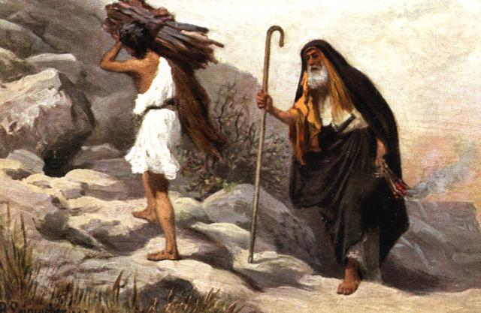
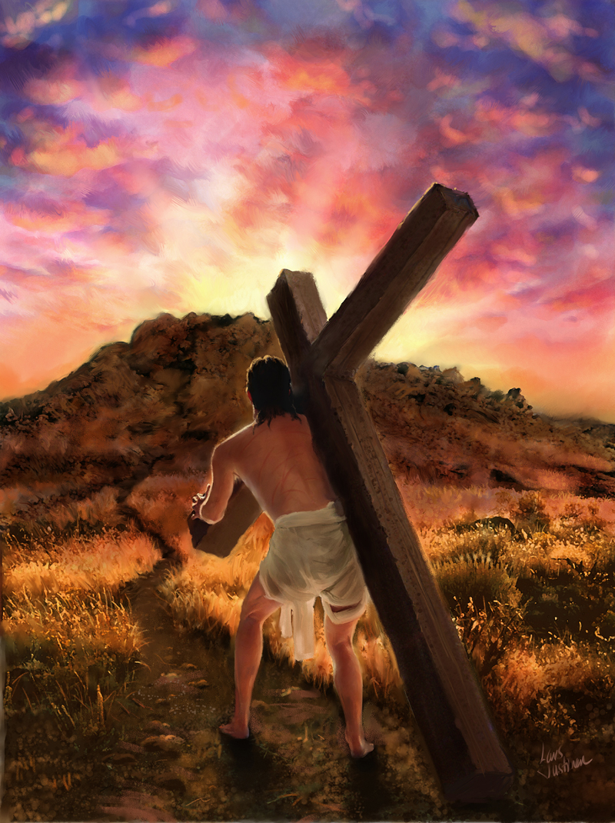

Genesis 22:7 where is the lamb for a burnt offering?

Where is the Lamb of God? Thousands of years of animal sacrifice were foreshadowing what? Isaac asked the right question for those living the Law of Moses, “where is the lamb?” For them, the atoning sacrifice was something for the future. Great faith was required to believe that the Son of God would come and offer himself up as the Lamb of God. There were many that had a hard time believing that the Lamb of God would ever come.

Nephi’s brother Jacob was accused of leading the people astray by encouraging them to worship “a being which ye say shall come many hundred years hence. And now Behold, I, Sherem, declare unto you that this is blasphemy; for no man knoweth of such things; for he cannot tell of things to come.” (Jacob 7:7) Korihor tried the same argument; he “began to preach unto the people that there should be no Christ… saying, O ye that are bound down under a foolish and a vain hope, why do ye yoke yourselves with such foolish things? why do ye look for a Christ? For no man can know of anything which is to come. Behold, these things which ye call prophecies… are foolish traditions of your fathers.” (Alma 30:12-14)

John Taylor
Isaac said to his father: "Behold the fire and the wood: but where is the lamb for a burnt offering?" What would you have thought if you had been in Abraham's place? Yet Abraham was a righteous man and sought after righteousness, sought after God, and God had talked with him, and blessed him in a very remarkable manner, and given him a son where there was no prospect naturally of his wife Sarah having one. How would you have felt, you fathers here, if you had been placed in the same position? (Journal of Discourses, 26 vols. [London: Latter-day Saints' Book Depot, 1854-1886], 24: 264)

Spencer W. Kimball
What a heavy heart and sad voice it must have been which replied: "My son, God will provide himself a lamb for a burnt offering." (Conference Report, October 1952, Second Day—Morning Meeting 48)

Genesis 22:9 they came to the place which God had told him of

Tradition has designated Mount Moriah as the site of Abraham’s offering. The place is holy to Jews, Christians, and Muslims (although Muslims believe Ishmael was the son of sacrifice). The Temple of Herod was built on the site. Currently, it is the site of the Muslim mosque, The Dome of the Rock.

“According to some Islamic scholars, the rock is the spot from which Muhammad ascended to Heaven accompanied by the angel Gabriel…

“The Foundation Stone and its surroundings is the holiest site in Judaism. Though Muslims now pray towards the Kaaba at Mecca, they once prayed with the Jews towards the raised platform on which the Dome of the Rock stands. Though Muhammad changed the direction of prayer for Muslims after a spat with a Jewish tribe, both groups traditionally regarded the location of the stone as the holiest spot on Earth, the site of the Holy of Holies during the Temple Period.” (http://en.wikipedia.org/wiki/Dome_of_the_Rock)

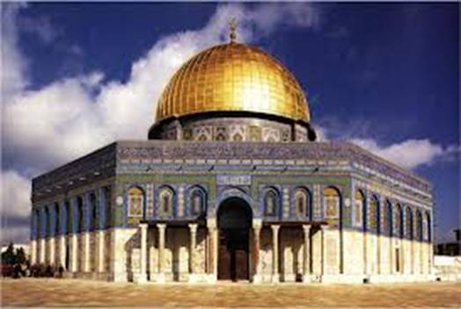

Genesis 22:9 Abraham… laid the wood in order, and bound Isaac his son

“Traditionally, an animal’s legs were bound before it was sacrificed. In Jewish literature the story of Abraham and Isaac is known as the Akedah, or ‘The Binding,’ in reference to Abraham binding his son.” (Ensign, Apr. 2013, 47)

Isaac was probably old enough to have resisted his father’s attempt to bind him. Not expressly written in the scriptures, we must assume that Isaac was older than just a boy, and therefore he was obedient as was Abraham. If Isaac was age 15, his father would have been 115. Certainly, he could have run away. Although we are not told the conversation between father and son at this point, we know that Isaac submitted to his father even as Jesus would later submit to His.

Neal A. Maxwell
Surely Abraham marveled at the submissiveness of his son Isaac, foreshadowing the later and more marvelous submissiveness of Jesus—for whom, however, there was no ram in the thicket!

Abraham and Isaac had undeniable cause for subdued rejoicing in the walk down Mount Moriah, when the latter's sacrifice proved unnecessary. Both had been obedient and submissive, in similitude of that which was to come in the meridian of time. Perhaps there even occurred a special father-and-son conversation, perhaps only rich and instructive silence. But the lesson given to Abraham was not being given to a novice or to an apprentice. The most advanced disciples—far from being immune from further instruction—experience even deeper and more constant tutorials. (Even As I Am [Salt Lake City: Deseret Book Co., 1982], 43)

Genesis 22:10 Abraham stretched forth his hand, and took the knife to slay his son

Abraham was really going to do it, “accounting that God was able to raise him up, even from the dead” (Heb. 11:19). Perhaps God would fulfill the promise another way, it didn’t matter. He had the faith; he was ready to cut when the angel stayed his hand.

Bruce C. Hafen
Joseph Smith taught that "a religion that does not require the sacrifice of all things never has power sufficient to produce the faith necessary unto life and salvation." Abraham, that archetype of the principle of sacrifice, was asked to sacrifice Isaac, his child of promise, under circumstances at least as irrational as those Job faced. In Abraham's case, he was asked to be the instrumentality of his own affliction, by performing the sacrifice himself. This alone placed God's request of Abraham beyond human ability to understand. In addition, to sacrifice Isaac was to destroy in one stroke all hope of fulfilling God's glorious promise that through the son of Abraham and Sarah the everlasting covenant would continue. Thus the image of Abraham standing over Isaac on the altar with a raised knife represents the ultimate leap of religious faith. There he stood, simultaneously at the height of faithful obedience and at the depth of personal anguish.

Then, by pure grace—in this instance through a ram in the thicket—God released Abraham from His awful commandment. In this striking symbol of the Atonement, God led Abraham into his soul's dark night, then transformed the experience into a moment of light. (The Broken Heart: Applying the Atonement to Life's Experiences [Salt Lake City: Deseret Book Co., 1989], 59)

Thomas S. Monson
All of us love the beautiful account from the Holy Bible of Abraham and Isaac. How exceedingly difficult it must have been for Abraham, in obedience to God's command, to take his beloved Isaac into the land of Moriah there to present him as a burnt offering. Can you imagine the heaviness of his heart as he gathered the wood for the fire and journeyed to the appointed place? Surely pain must have racked his body and tortured his mind as he bound Isaac and laid him on the altar upon the wood and stretched forth his hand and took the knife to slay his son. How glorious was the pronouncement, and with what wondered welcome did it come, "Lay not thine hand upon the lad, neither do thou any thing unto him: for now I know that thou fearest God seeing thou has not withheld thy son, thine only son from me." (Gen. 22:12.)

As God witnessed the suffering of Jesus, his Only Begotten Son in the flesh, and beheld his agony, there was no voice from heaven to spare the life of Jesus. There was no ram in the thicket to be offered as a substitute sacrifice. "For God so loved the world that he gave his only begotten Son that whosoever believeth in him should not perish, but have everlasting life." (Conference Report, October 1965, Afternoon Meeting 142)

Joseph Smith
The sacrifice required of Abraham in the offering up of Isaac, shows that if a man would attain to the keys of the kingdom of an endless life, he must sacrifice all things. (History of the Church, 5:555.)

John Taylor
I speak of these things to show how men are to be tried. I heard Joseph Smith say—and I presume Brother Snow heard him also—in preaching to the Twelve in Nauvoo, that the Lord would get hold of their heart strings and wrench them, and that they would have to be tried as Abraham was tried. Well, some of the Twelve could not stand it. They faltered and fell by the way. It was not everybody that could stand what Abraham stood. And Joseph said that if God had known any other way whereby he could have touched Abraham's feelings more acutely and more keenly he would have done so. It was not only his parental feelings that were touched. There was something else besides. He had the promise that in him and in his seed all the nations of the earth should be blessed; that his seed should be multiplied as the stars of the heaven and as the sand upon the seashore. He had looked forward through the vista of future ages and seen, by the spirit of revelation, myriads of his people rise up through whom God would convey intelligence, light and salvation to a world. But in being called upon to sacrifice his son it seemed as though all his prospects pertaining to posterity were to come to naught. But he had faith in God, and he fulfilled the thing that was required of him. Yet we cannot conceive of anything that could be more trying and more perplexing than the position in which he was placed. (Journal of Discourses, 24:264)

Genesis 22:13 behold behind him a ram caught in a thicket

Neal A. Maxwell
Can we, even in the depths of disease, tell [Jesus] anything at all about suffering? In ways we cannot comprehend, our sicknesses and infirmities were borne by Him even before they were borne by us. The very weight of our combined sins caused Him to descend below all. We have never been, nor will we be, in depths such as He has known. Thus His atonement made perfect His empathy and His mercy and His capacity to succor us, for which we can be everlastingly grateful as He tutors us in our trials. There was no ram in the thicket at Calvary to spare Him, this Friend of Abraham and Isaac. (Even As I Am, pp. 116-17)

Genesis 22:14 Jehovah-jireh… In the mount of the Lord it shall be seen

The mount in Moriah is where Abraham saw the mercy of the Lord. To expound upon the meaning of the phrase “in the mount of the Lord it shall be seen”:

- “in the mount of the Lord [the love of God for his obedient servants] shall be seen.”
- “in the mount of the Lord [God’s mercy in staying the prophet’s hand] shall be seen.
- “in the mount of the Lord, God will provide a ram in the thicket”
- “in the mount of the Lord, God will provide a lesson for Abraham he will never forget.”
- “for in the mount of the Lord, Abraham will see what God, the Father had to go through in sacrificing His Only Begotten Son.”

Melvin J. Ballard
I think as I read the story of Abraham's sacrifices of his son Isaac that our Father is trying to tell us what it cost him to give his Son as a gift to the world. You remember the story of how Abraham's son came after long years of waiting and was looked upon by his worthy sire, Abraham, as more precious than all his other possessions; yet, in the midst of his rejoicing, Abraham was told to take this only son and offer him as a sacrifice to the Lord. He responded. Can you feel what was in the heart of Abraham on that occasion? You love your son just as Abraham did; perhaps not quite so much, because of the peculiar circumstances, but what do you think was in his heart when he started away from Mother Sarah, and they bade her goodbye? What do you think was in his heart when he saw Isaac bidding farewell to his mother to take that three days' journey to the appointed place where the sacrifice was to be made? I imagine it was about all Father Abraham could do to keep from showing his great grief and sorrow at that parting, but he and his son trudged along three days toward the appointed place, Isaac carrying the fagots that were to consume the sacrifice. The two travelers rested, finally, at the mountainside, and the men who had accompanied them were told to remain while Abraham and his son started up the hill.

The boy then said to his father: "Why, Father, we have the fagots; we have the fire to burn the sacrifice; but where is the sacrifice?"

It must have pierced the heart of Father Abraham to hear the trusting and confiding son say: "You have forgotten the sacrifice." Looking at the youth, his son of promise, the poor father could only say: "The Lord will provide."

They ascended the mountain, gathered the stones together, and placed the fagots upon them. Then Isaac was bound, hand and foot, kneeling upon the altar. I presume Abraham, like a true father, must have given his son his farewell kiss, his blessing, his love, and his soul must have been drawn out in that hour of agony toward his son who was to die by the hand of his own father. Every step proceeded until the cold steel was drawn, and the hand raised that was to strike the blow to let out the life's blood when the angel of the Lord said: "It is enough."

OUR Father in heaven went through all that and more, for in his case the hand was not stayed. He loved his Son, Jesus Christ, better than Abraham ever loved Isaac, for our Father had with him his Son, our Redeemer, in the eternal worlds, faithful and true for ages, standing in a place of trust and honor, and the Father loved him dearly, and yet he allowed this well-beloved Son to descend from his place of glory and honor, where millions did him homage, down to the earth, a condescension that is not within the power of man to conceive. He came to receive the insult, the abuse, and the crown of thorns. God heard the cry of his Son in that moment of great grief and agony, in the garden when, it is said, the pores of his body opened and drops of blood stood upon him, and he cried out: "Father, if thou be willing, remove this cup from me."

I ask you, what father and mother could stand by and listen to the cry of their children in distress, in this world, and not render aid and assistance? I have heard of mothers throwing themselves into raging streams when they could not swim a stroke to save their drowning children, rushing into burning buildings, to rescue those whom they loved.

We cannot stand by and listen to those cries without its touching our hearts. The Lord has not given us the power to save our own. He has given us faith, and we submit to the inevitable, but he had the power to save, and he loved his Son, and he could have saved him. He might have rescued him from the insult of the crowds. He might have rescued him when the crown of thorns was placed upon his head. He might have rescued him when the Son, hanging between the two thieves, was mocked with, "Save thyself, and come down from the cross. He saved others; himself he cannot save." He listened to all this. He saw that Son condemned; he saw him drag the cross through the streets of Jerusalem and faint under its load. He saw that Son finally upon Calvary; he saw his body stretched out upon the wooden cross; he saw the cruel nails driven through hands and feet, and the blows that broke the skin, tore the flesh, and let out the life's blood of his Son. He looked upon that.

In the case of our Father, the knife was not stayed, but it fell, and the life's blood of his Beloved Son went out. His Father looked on with great grief and agony over his Beloved Son, until there seems to have come a moment when even our Savior cried out in despair: "My God, my God, why hast thou forsaken me?"

In that hour I think I can see our dear Father behind the veil looking upon these dying struggles until even he could not endure it any longer; and, like the mother who bids farewell to her dying child, has to be taken out of the room, so as not to look upon the last struggles, so he bowed his head, and hid in some part of his universe, his great heart almost breaking for the love that he had for his Son. Oh, in that moment when he might have saved his Son. I thank him and praise him that he did not fail us, for he had not only the love of his Son in mind, but he also had love for us. I rejoice that he did not interfere, and that his love for us made it possible for him to endure to look upon the sufferings of his Son and give him finally to us, our Savior and our Redeemer. Without him, without his sacrifice, we would have remained, and we would never have come glorified into his presence. And so this is what it cost, in part, for our Father in Heaven to give the gift of his Son unto men.

HOW do I appreciate the gift? If I only knew what it cost our Father to give his Son, if I only knew how essential it was that I should have that Son and that I should receive the spiritual life that comes from that Son, I am sure I would always be present at the sacrament table to do honor to the gift that has come unto us. (Bryant S. Hinckley, Sermons and Missionary Services of Melvin J. Ballard [Salt Lake City: Deseret Book Co., 1949], 152-155)

Genesis 22:17 I will multiply thy seed as the stars of the heaven

Neal A. Maxwell
Anciently, the vastness of Abraham’s eventual posterity was compared to the sand of the sea, a staggering promise (see Gen. 22:17). The Restoration’s revelations and translations accommodate a vast universe; thus it is no surprise to us that scientists’ latest estimate of the number of stars in the universe is approximately 70 sextillion—“more stars in the sky,” scientists say, “than there are grains of sand in every beach and desert on Earth” (Allison M. Heinrichs, “The Stellar Census: 70 Sextillion,” Los Angeles Times, 26 July 2003; see also Carl Sagan, Cosmos [1980], 196). (Conference Report, Oct. 2003, 100)

George Q. Cannon
There was to be no end to the kingdom of Abraham, he was to have thrones, principalities and dominions; to be crowned not with a barren, empty crown, not a crown without a kingdom, but a real one, emblematical of endless and boundless rule, power, dominion and glory. The Lord has promised the same glory to every being who attains to the glory of the sun, who gains a fullness of glory in his celestial kingdom. (Journal of Discourses, 15:299)

Genesis 22:18 in thy seed shall all the nations of the earth be blessed

John Taylor
We read that [in the Kirtland Temple]… “Elias appeared, and committed the dispensation of the gospel of Abraham, saying that in us and our seed all generations after us should be blessed.”

That was the promise made to Abraham some 3,500 years ago. It was not a promise made to Abraham alone, but through him to others. He and his seed were to be the instrumentality, the media through which mankind should be blessed; they were to be the special instruments in the hands of God for the accomplishment of these purposes. (Journal of Discourses, 25:180)

Bruce R. McConkie
In the nearly four thousand years since Abraham, uncounted millions of his literal seed have lived in the world, most of them in a day when the gospel, with its saving ordinances and truths was not found among men. Yet the Lord promised Abraham, their father that these millions who have sprung from him, these millions who are his literal seed, these hosts of his posterity who comprise a major portion of a multitude of nations, that all these are entitled by lineage and as of right to the blessings of the priesthood, of the gospel, of salvation, and of eternal life.

Well, we are latter-day Israel; we are part of the seed of Abraham; we hold the power and authority of this priesthood; we are a light to the gentile nations, and as a result we are under command to carry the message of salvation to them. But we are also chosen and appointed to be saviors to Israel itself, to the seed of Abraham—to the whole kingdom and nation of people of the chosen lineage, who have lived in all the days since Abraham—whether they lived when the gospel was here or whether they did not. (Conference Report, April 1959, Afternoon Meeting 118)

